AWS - Landing Zone Design
AllCargo Logistics (GATI) – GEMS 2.0

Prepared by: Keerthivasan V
Table of Contents
Introduction 2
Design Decisions 2
Landing Zone 4
High Level Design 4
Low Level Design 5
Account Strategy 5
Identity & Access Management 9
Networking 11
Security 17
Operational Excellence 22
logging and Monitoring 23
Tagging 24

Introduction
AllCargo Logistics (GATI) engaged Rackspace to provide them with a well architected landing zone design and build which will act as a platform to migrate all their applications from their onprem environment to AWS. The design is focussed towards multiple areas which will be discussed with customer and this document will act as a comprehensive guide to get an understanding on their landing zone. Building a landing zone involves technical and business decisions to be made across account structure, networking, security, and access management in accordance with your organization’s growth and business goals for the future.

Design Decisions
Account Structure
SLNo | Decisions
1 | Multi Account Structure for GATI, where a dedicated master payer account created for GATI
2 | Under GATI Root OU the OU’s are segregated based on the environments.

Identity & Access Management
SLNo | Decisions
1 | GATI has an Azure AD which will be integrated to the AWS IAM Identity center (AWS SSO) which will be used for authorization.
2 | Privileged escalation will be enabled by using TEAMS as suggested by AWS
3 | External users will be allowed to access AWS by inviting them to Azure AD

Networking
SLNo | Decisions
1 | Use TransitGateway to Inter-connect VPC.
2 | Use a centralised Egress VPC to route outgoing internet traffic.
3 | Use a centralised Ingress VPC to route incoming ingress traffic.
4 | Inspect egress VPC with appliance based firewall using AWS Network firewall.
5 | Inspect ingress VPC with WAF as it is only a http/https based traffic.
6 | OpenVPN cloud Connexa will be used as a Client VPN solution.

Security
SLNo | Decisions
1 | Use KMS for Encryption at rest.
2 | Use AWS ACM for Encryption at Transit.
3 | Security lake services will be used to centralise the VPC Flow logs and Cloudtrail logs
4 | SIEM Integration using QRadar at onpremises

logging & Monitoring
SLNo | Decisions
1 | VPC Flow logs centralised using security lake services
2 | Cloudtrail logs centralised using security lake services

Tagging
SLNo | Decisions
1 | Particular tags have been decided to be used for all the AWS resources.

Landing Zone

High Level Design
Below diagram shows the aws landing zone estate for All Cargo Logistics (GATI).
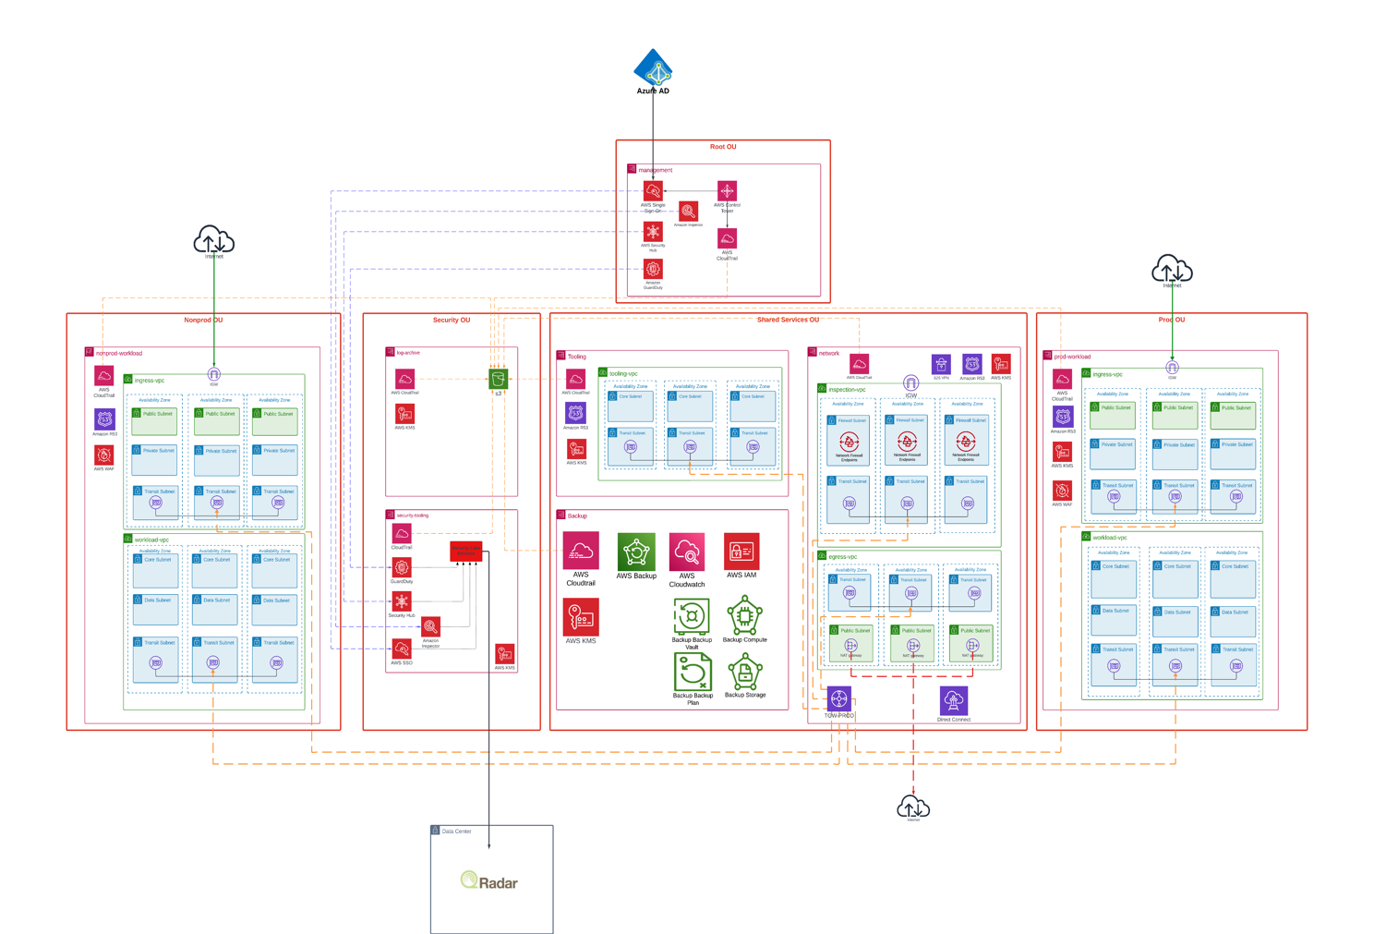
The above diagram shows the high-level view of the landing zone created for AllCargo Logistics (GATI). The dia shows 4 OUs – Nonprod, Security, Shared Services, Sandbox and Prod.
The Prod and Nonprod OU hosts the workloads for the respective environments, this environment will host all the application workloads on EKS, EC2, API Gateway etc.

Security OU hosts 2 accounts, the security tooling account which would be the delegated administrator for IAM identity center, Guard Duty, Security Hub, and Security Lake services. The log-archive account acts as the centralised account for storing the security logs.

The Shared Services account consists of Tooling, Network and Backup account each consisting of workloads for their respective functionalities. Network account is primarily responsible for hosting networking solutions related to AWS Network Firewall, VPN, Direct Connect, Transit Gateway etc. Tooling account will host the Devops tools, security tool deployments. Backup account will host the backup services for the entire landing zone which will be used to store the backups of the AWS services.

The Sandbox OU consists of any sandbox accounts required for testing and POCs.

Low Level Design

Account Strategy
Using multiple AWS accounts to help isolate and manage your business applications and data can help you optimize across most of the AWS Well-Architected Framework pillars including operational excellence, security, reliability, and cost optimization
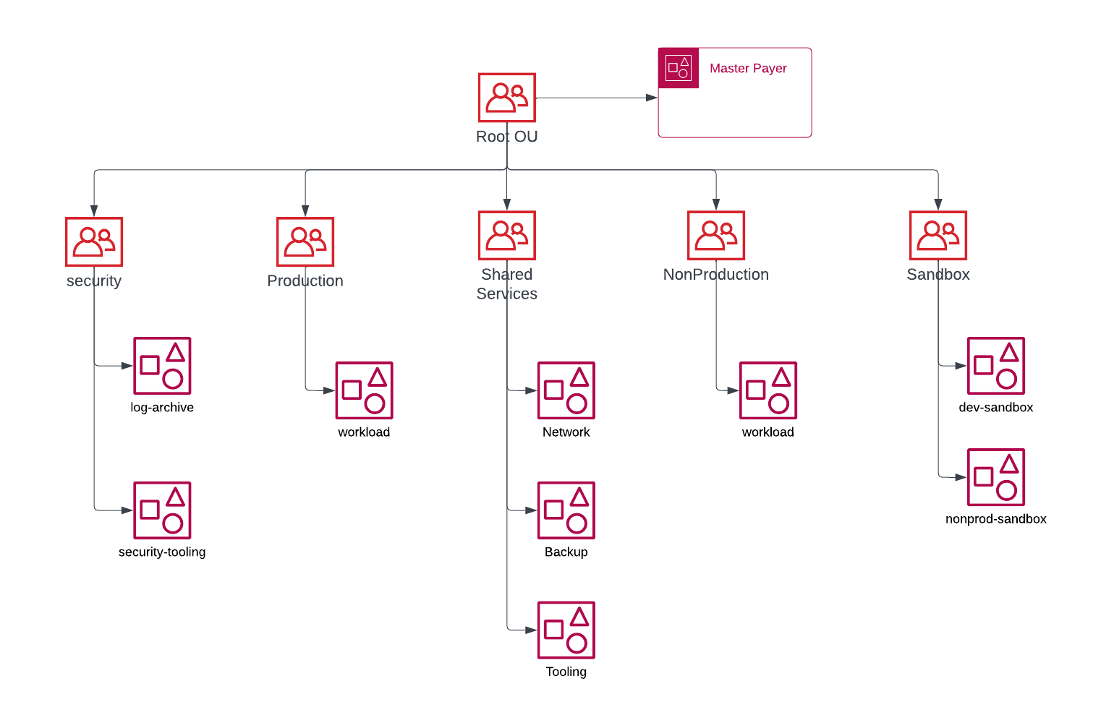

Root OU
The parent container for all the accounts for the customer organization. If you apply a policy to the root, it applies to all organizational units (OUs) and accounts in the organization.

Management Account is the account that is provisioned at first for the new landing zone. This account will be used for consolidated billing for everything in the new landing zone. It will also be used for provisioning new AWS accounts through Account Factory, managing AWS Organizations Units & guardrails and managing user access & permission set through AWS Single Sign-On.
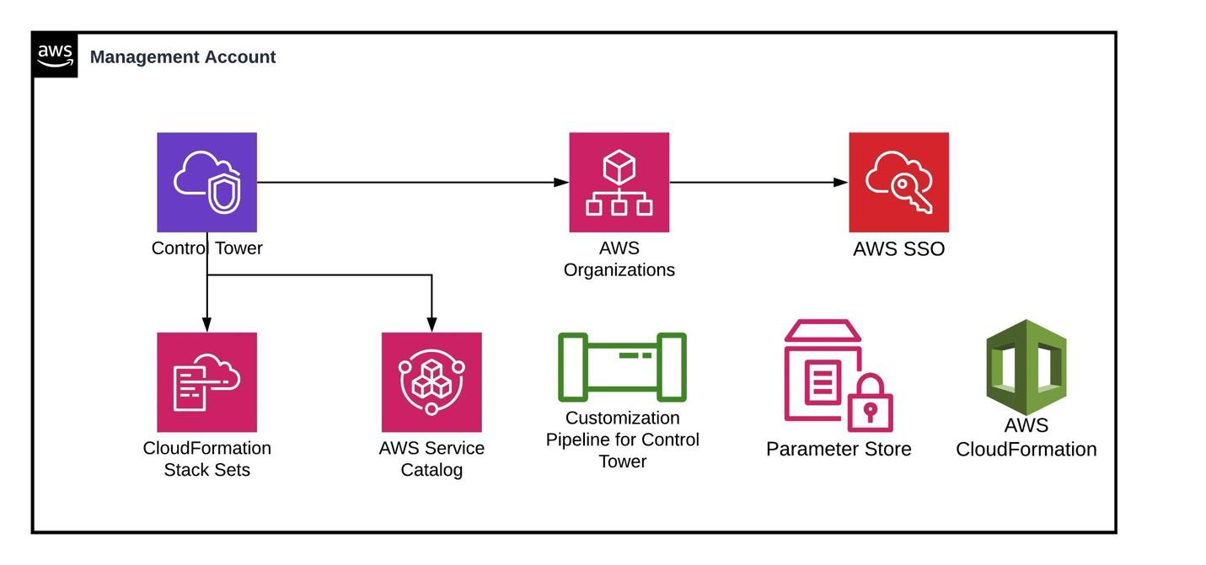
An Organizational Unit (OU) is a group of accounts that can be administered and managed together as a single unit. When a policy is attached to an OU, it flows down and affects all the accounts that are part of it. As part of AllCargo Logistics (GATI) Landing zone, following Organizational Units will be created for managing different types of AWS Accounts.

Security OU
This OU will get created by default as part of AWS Control Tower setup and it will contain the log-archive and security-tooling accounts, which also get created by default as part of AWS Control Tower setup. Please note that the security-tooling account will have a customized name to substitute for the initial Audit account name. We are changing the terminology regarding the default name of this account to align with the AWS multi-account strategy.

Security-Tooling Account
The security-tooling account is dedicated to operating security services, monitoring AWS accounts, and automating security alerting and response.
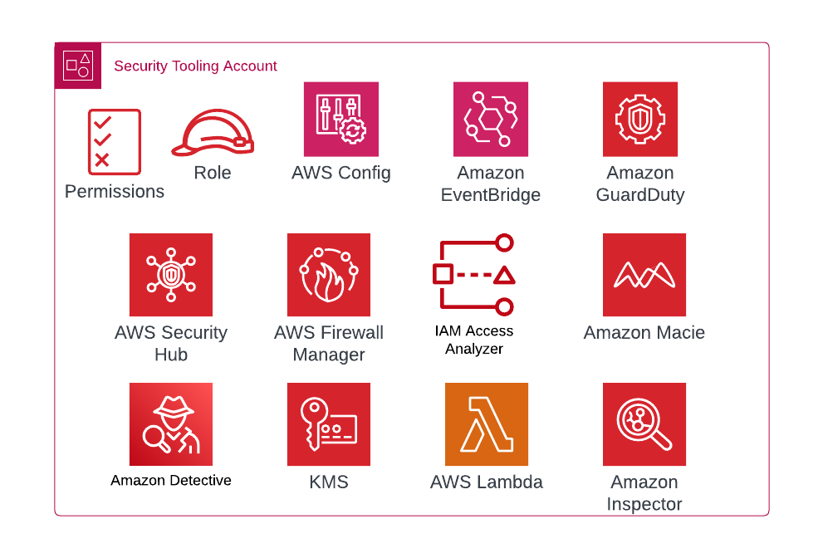
The security objectives include the following:
- Provide a dedicated enclave with controlled access to manage access to the security guardrails, monitoring, and response.
- Maintain the appropriate centralized security infrastructure to monitor security operations data and maintain traceability. Detection, investigation, and response are essential parts of the security lifecycle and can be used to support a quality process, a legal or compliance obligation, and for threat identification and response efforts.
- Further support a defence-in-depth strategy by maintaining another layer of control over appropriate security configuration and operations such as encryption keys and security group settings. This is an account where security operators work. Read-only/audit roles to view AWS organization-wide information are typical, whereas write/modify roles are limited in number, tightly controlled, monitored, and logged.
When you enable IAM Identity Center, your IAM Identity Center instance is created in the management account in AWS Organizations by default. This was originally designed this way so that IAM Identity Center can provision, deprovision, and update roles across all your AWS Organization's member accounts. Even though your IAM Identity Center instance must always reside in the management account, you can choose to delegate administration of IAM Identity Center to a member account in AWS Organizations, thereby extending the ability to manage IAM Identity Center from outside the management account.

Enabling delegated administration provides the following benefits:
- Minimizes the number of people who require access to the management account to help mitigate security concerns.
- Allows selected administrators to assign users and groups to applications and to your AWS Organization's member accounts.
The security-tooling account is dedicated to be registered as the delegated Administrator for IAM Identity Center.

Log-Archive Account
The log-archive account is dedicated to ingesting and archiving all security-related logs and backups. With centralized logs in place, you can monitor, audit, and alert on Amazon S3 object access, unauthorized activity by identities, IAM policy changes, and other critical activities performed on sensitive resources.
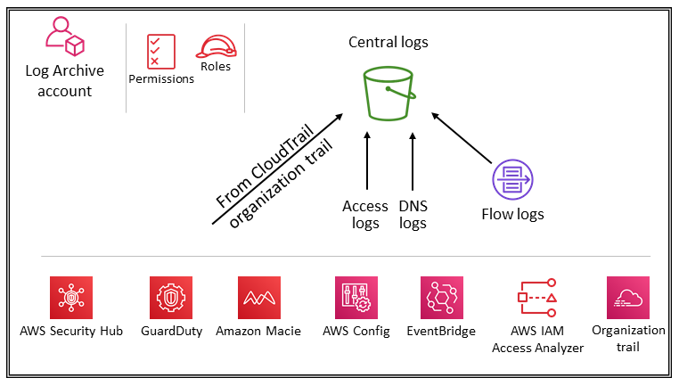
The security objectives are straightforward: this should be immutable storage, accessed only by controlled, automated, and monitored mechanisms, and built for durability (for example, by using the appropriate replication and archival processes). Controls should be implemented at depth to protect the integrity and availability of the logs and log management process. In addition to preventive controls, such as assigning least access privilege roles to be used for access and encrypting logs with a controlled AWS KMS key, use detective controls such as AWS Config to monitor (and alert and remediate) this collection of permissions for unexpected changes.

Production OU
The production OU will host all the accounts where the production workloads would be deployed and based on the requirement and design the workloads will either be deployed in a single account or multiple account.

Workload Account
Workload account is where the actual production workloads/Applications would be deployed. This account has to secured to ensure the production applications are secure by using the appropriate network patterns.
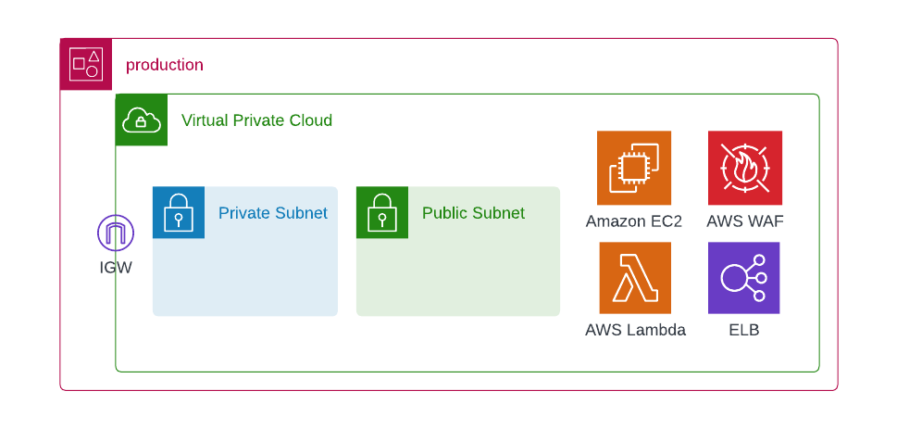

Shared Services OU
The Shared Services OU is where the shared network services, Devops and Backup services would be deployed this shared services OU will be per entity and will only host services related to the specific Entity OU.

Network Account
The Network account under the Entity OU will host the network components like Egress VPC, Inspection VPC, Transit Gateway and services which establishes the network connections across the VPCs, Internet, Datacentres and Branch Offices.
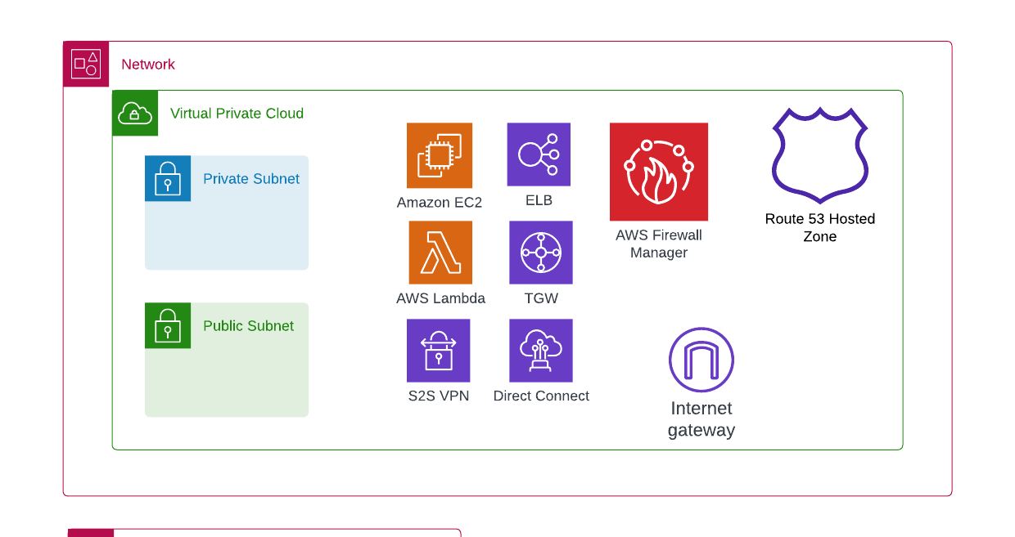

Tooling Account
Tooling account in the shared services OU under each entity OU will host the services which are required to monitor the platform, configuration management, CICD tools etc. This account will be used by the entire entity team to create platform to host application build and deployment pipelines, also this team will be used to centralise all the monitoring metrics to have a dashboard in this account to have a single pane of glass view.
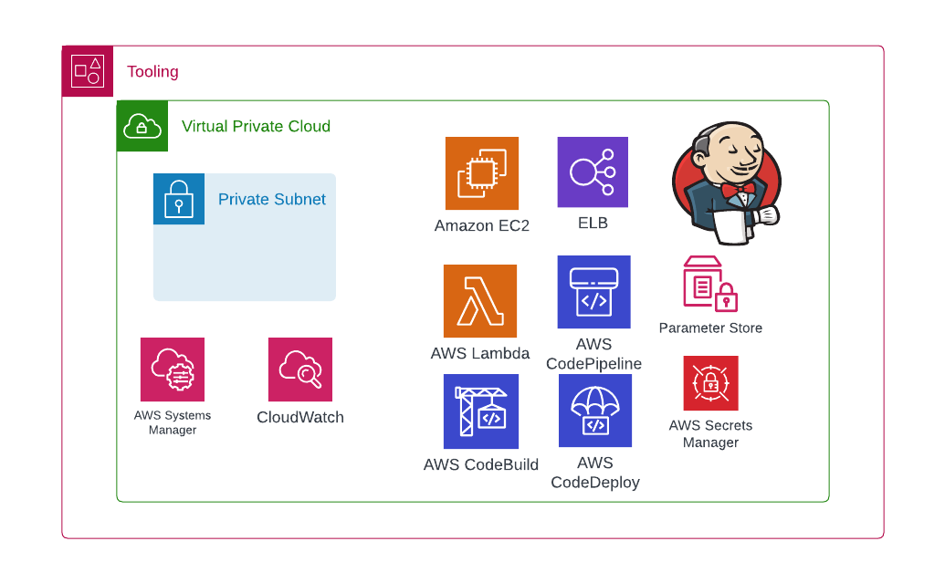

Backup Account
Backup account in the shared services OU under each entity will host the AWS Backup services which are responsible to take backups of the AWS resources and store them securely. These AWS services for which backups are taken can be stored in the same region or can be stored in multiple regions.
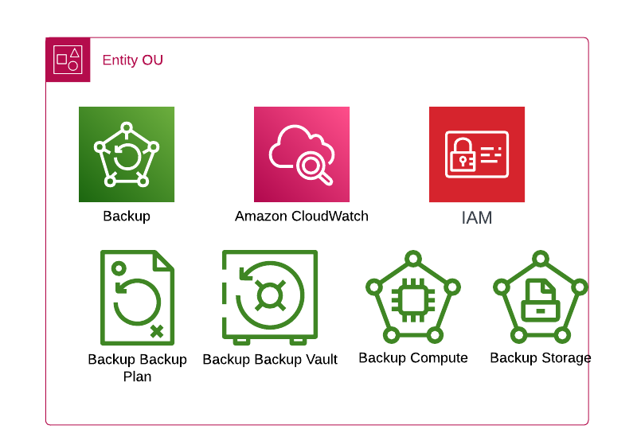

Non-Production OU
The non-production OU will host all the accounts where the non-production workloads would be deployed and based on the requirement and design the workloads will either be deployed in a single account or multiple account.

Workload Account
Workload account is where the actual workloads would be deployed. This account must be secured to ensure the applications are secure.
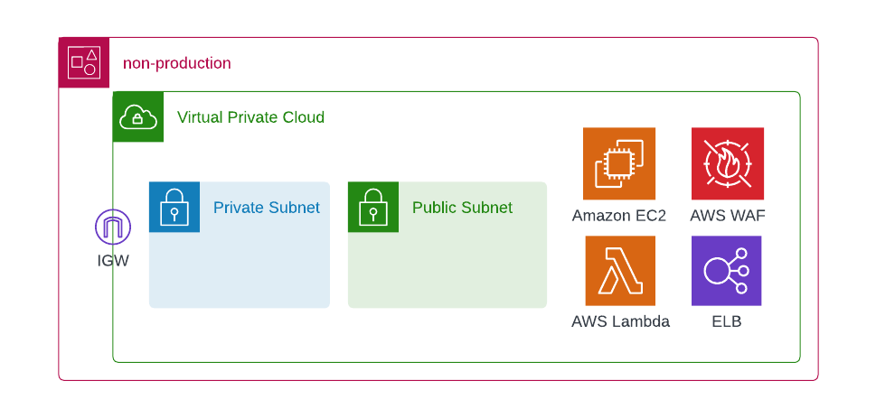

Sandbox OU
The Sandbox OU will have AWS accounts that are used for POC or Cloud enablement purpose for the team, the sandbox OU can be created per user or per workload depending on the requirement.

Identity & Access Management
In AWS Control Tower, IAM Identity Center allows central cloud administrators and end users to manage access to multiple AWS accounts and business applications.
Based on the discussions and decisions in the workshop, the users are groups are natively managed in Azure AD which will be integrated to IAM Identity Center. All the users in the Azure AD will have the MFA enabled to ensure there are appropriate security protections for each users trying to access AWS. Below section provides further information on how to integrate AWS IAM Identity center with Azure AD.

The security-tooling account will act as a delegated administrator for IAM Identity Center.

IAM Users/Roles/Groups
IAM users in aws are used to authenticate to AWS Console or to AWS CLI/SDK. AllCargo Logistics (GATI) can create an IAM user based on the requirement, although SSO would be the primary way to login to AWS Console. But the requirement is to use IAM Roles for any automation would need to be created appropriately.
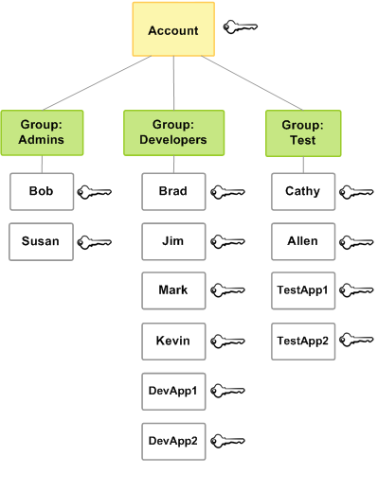

IAM permissions
Every principal created in AWS will be associated with a set of IAM permissions to provide authorization to the AWS services. The permissions must be created based on the requirements if there are any custom users.

Azure AD Integration with IAM Identity Center
AllCargo Logistics (GATI) uses Azure AD to manage the domain users and it must be extended to AWS via the AWS IAM Identity centers where we use an external identity provider like Azure AD in IAM Identity center.

AllCargo Logistics (GATI) needs to configure the Azure AD by adding an AWS SSO enterprise application on Entra administrative center and this configuration allows the connectivity from AWS IAM Identity center to Azure and sync the users between Azure and AWS. We can then create the permission sets and assign the scopes to the permission sets as shown below.
Permission Sets | Accounts/OU
GATI_LZ_Administrator | All OUs
GATI_Security_Administrator | Security OU
GATI_Network_Administrator | Shared Services OU, Production OU, NonProduction OU
GATI_Application_Administrator | Production OU, NonProduction OU

A permission set contains policies that determine a user's permissions to access an AWS account. When you assign a user or group to a permission set in an AWS account, IAM Identity Center creates an IAM role in the account and attaches the policies specified in the permission set to that role.
Single sign on the primary way to allow access to the AWS console for the AllCargo Logisitics (GATI) but for external users outside the GATI, the AD Administrator need to invite the external users to the GATI Azure AD

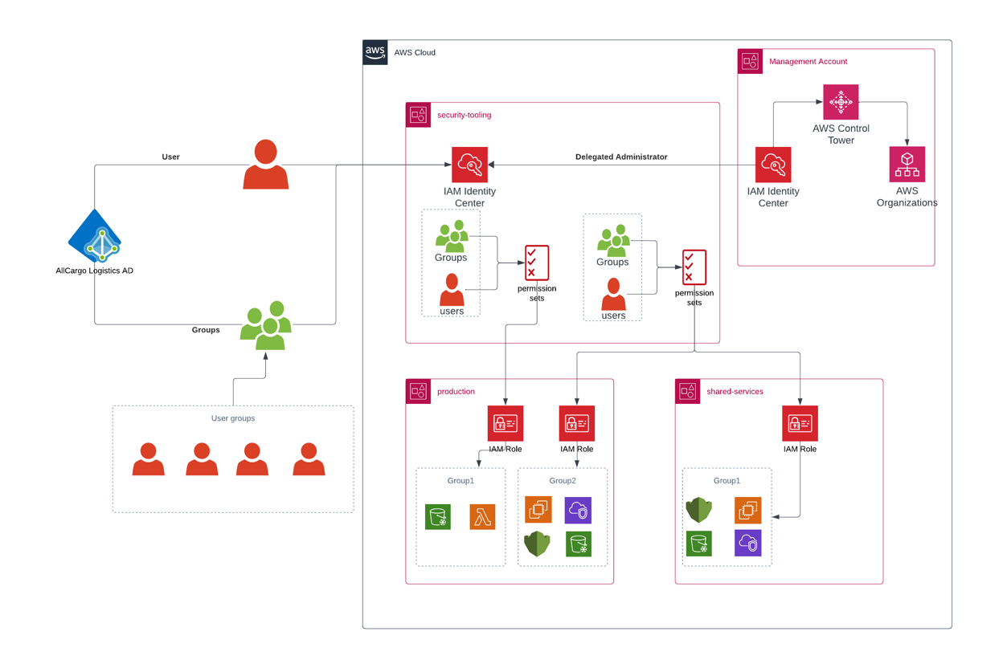
Note:
For temporary elevated access management we can use TEAM an open source solution that integrates with IAM identity center and allows you to manage and monitor time bound elevated access to your multi account AWS environment at scale.
Follow below link for deployment.

Networking
The AWS worldwide infrastructure consists of regions and, within those regions, are availability zones. AllCargo Logistics (Gati) will be utilizing all the availability zones in the below region.
Region | Availability Zones
ap-south-1 | ap-south-1a
ap-south-1 | ap-south-1b
ap-south-1 | ap-south-1c

VPC
Amazon Virtual Private Cloud (Amazon VPC) enables you to launch Amazon Web Services resources into a virtual network you've defined. This virtual network resembles a traditional network that you'd operate in your own data centre, with the benefits of using the scalable infrastructure of AWS. All the entities of the AllCargo Logistics (Gati) would create their resources under a VPC of its own or on a shared VPC.
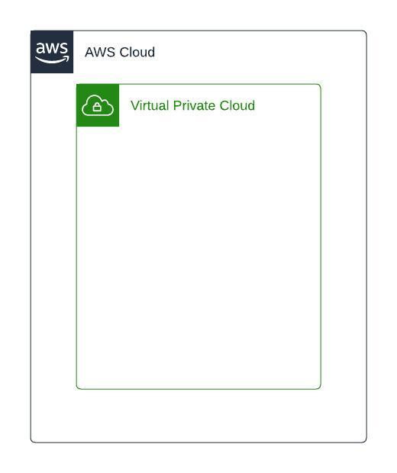

Private Subnet
Subnet is a logical segregation of VPC and is created under a VPC and private subnet is where any internal application which must be accessed within the VPC will be created. All the resources deployed within the private subnet will not be accessible from internet.
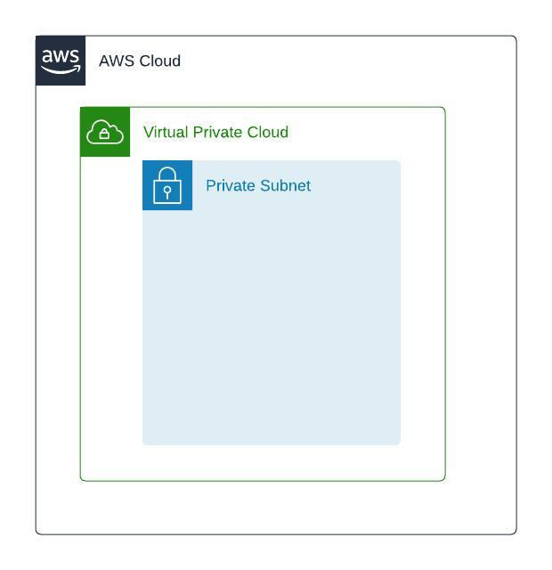

Internet Gateway
Internet gateway is a resource type in AWS which is used to provide internet access to the VPC and can be attached at a VPC level.
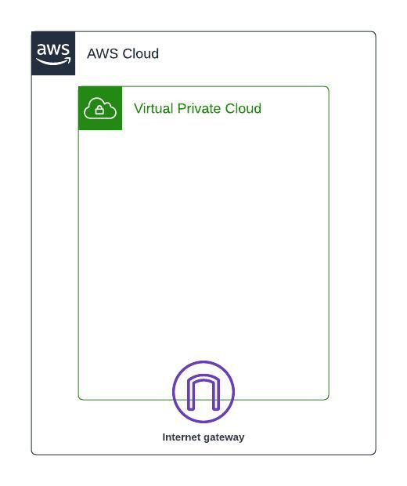

Public Subnet
A subnet can be created as a public if there is a route to internet via internet gateway. Any Internet facing application for AllCargo Logistics(GATI) will be deployed in the public subnet.
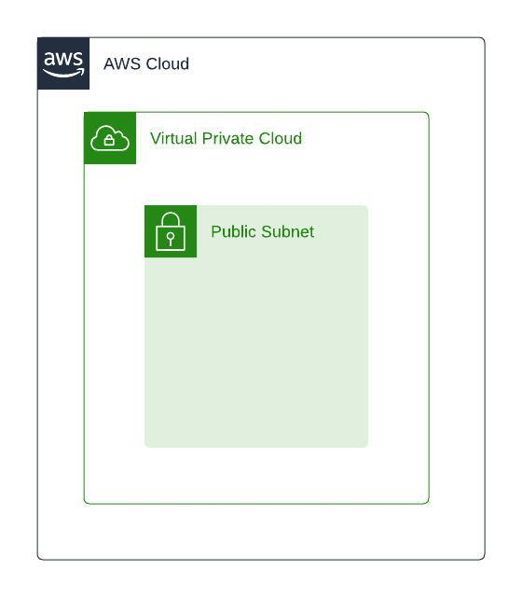

Availability zones
Availability Zones consist of one or more discrete data centers, each with redundant power, networking, and connectivity, and housed in separate facilities. These Availability Zones enable you to operate production applications and databases that are more highly available, fault tolerant, and scalable than possible when using a single data center. You can deploy your applications and databases across multiple Availability Zones. In the unlikely event of a failure of one Availability Zone, user requests are routed to your application instances in the second Availability Zone. This approach ensures that your application continues to always remain available.
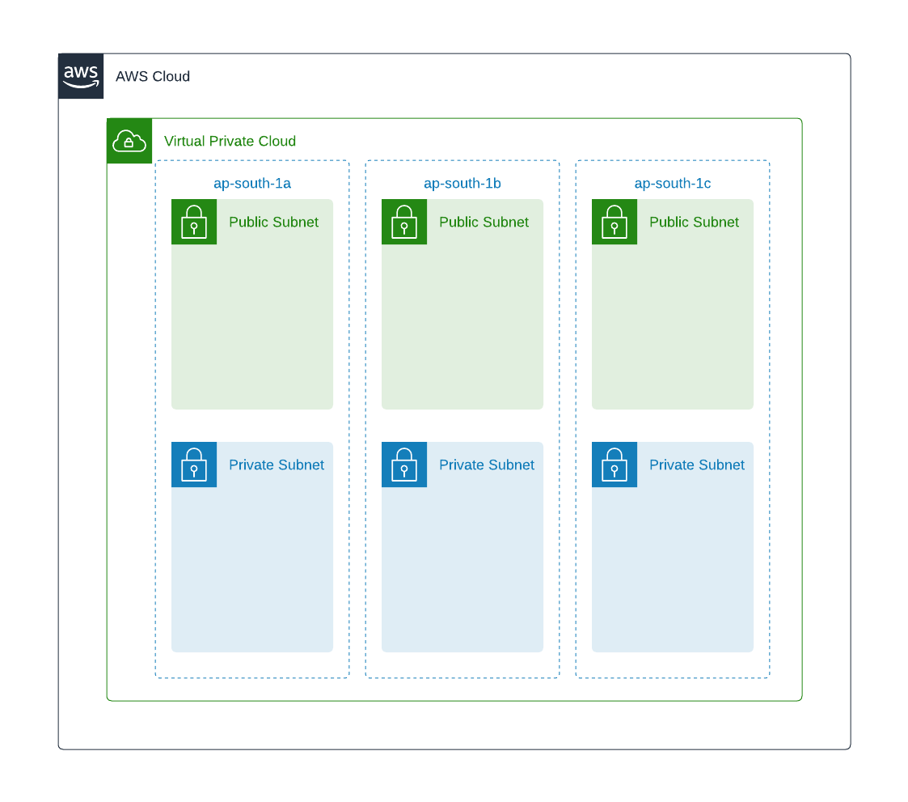
Each application in AllCargo Logistics (GATI) will be created in 3 availability zones in Mumbai region.

Multi VPC connectivity
To create a mesh network of multiple VPC to form a single network, team needs the ability to connect multiple VPC’s together to ensure the connectivity can be extended across the network. There are multiple options to extend or connect the VPC’s together.

Peering
A VPC peering connection is a networking connection between two VPCs that enables you to route traffic between them using private IPv4 addresses or IPv6 addresses. Instances in either VPC can communicate with each other as if they are within the same network.
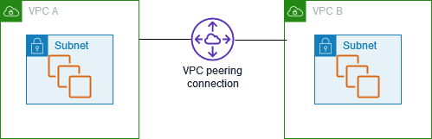
You can create a VPC peering connection between your own VPCs, or with a VPC in another AWS account. The VPCs can be in different Regions (also known as an inter-Region VPC peering connection).

Transit Gateway
A transit gateway is a network transit hub that you can use to interconnect your virtual private clouds (VPCs) and on-premises networks. Each VPC will have a transit subnet where a transit gateway attachment to attach the VPC’s to a transit gateway is created which will in turn route the traffic to other VPC’s based on the routes configured in the transit gateway route table. Below diagram shows how to configure TGW to interconnect multiple VPCs in the AWS account
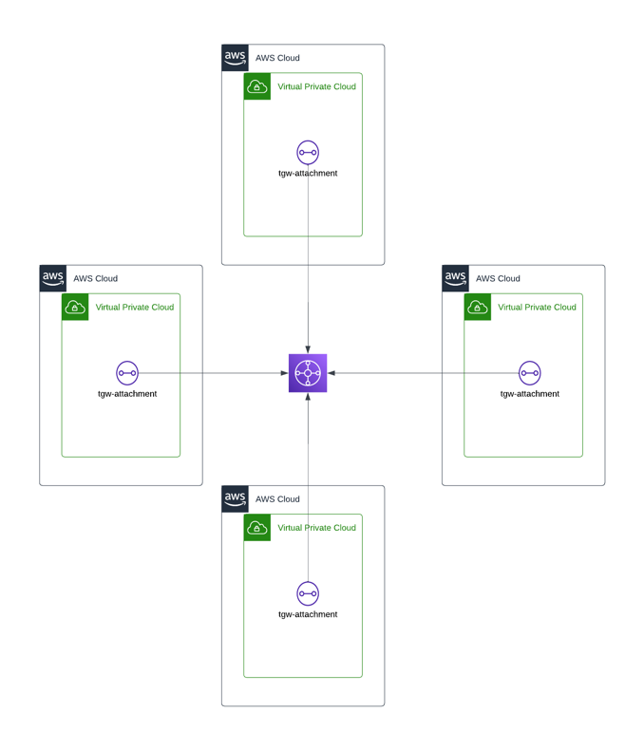
This would be the preferred approach for connecting multiple VPC’s together.

Internet Traffic
Any traffic from internet into the workload VPC will be inspected by the firewall in the inspection VPC of the network account and this firewall will evaluate if the traffic must be allowed in to the VPC or to be blocked. The diagram shows the details on the connectivity regarding the route tables.
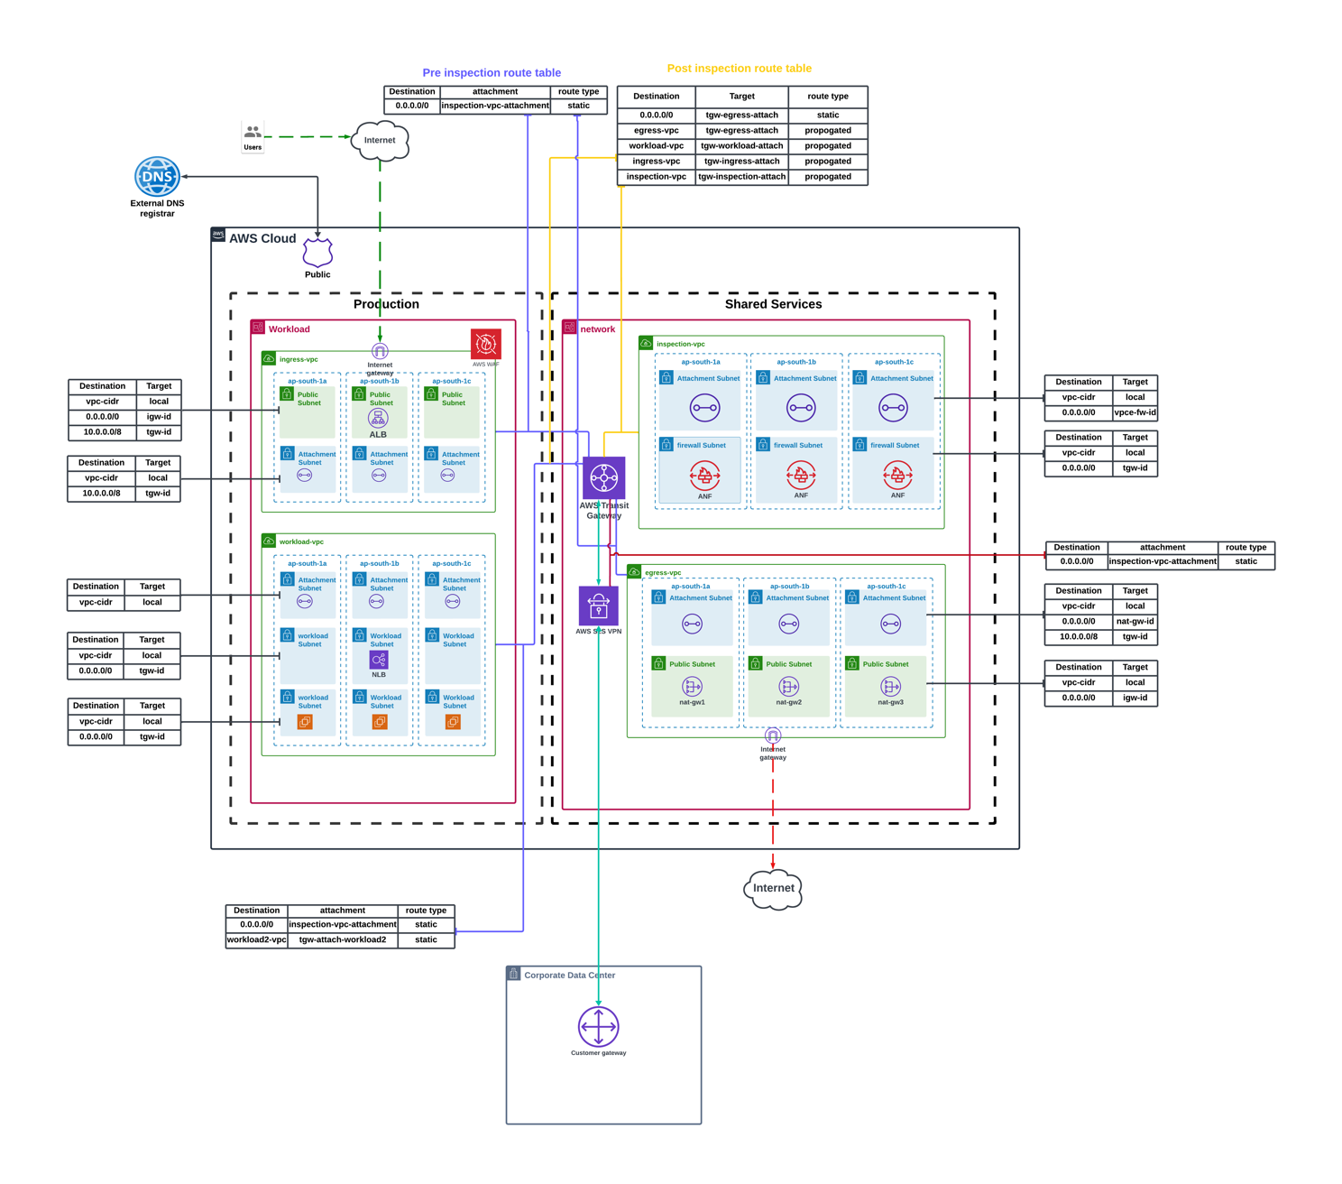

Ingress Traffic
- Traffic from internet reaches the ingress-vpc via the internet gateway.
- Traffic from ingress vpc is routed to the transit gateway which forwards the traffic to the inspection-vpc in the shared-services account.
- The traffic after inspected by the AWS network firewall will route the traffic to the private subnet in the workload account.
- The internet traffic reaching the public subnet will be secured for layer 7 filtering using the AWS Web Application Firewall(WAF)

Egress Traffic
- Traffic from the instance in workload VPC in the workload OU destined to the internet is routed to the Transit Gateway. The Transit Gateway route table associated with the attachment sends all the traffic (0.0.0.0/0) to the inspection VPC in the network account.
- The TGW subnet route table of the network account sends the traffic to the AWS Network firewall which will inspect the egress traffic.
- The traffic based on the firewall rules in the AWS Network firewall either will be allowed or denied.
- The allowed traffic from the firewall will be routed to the NAT Gateway and will reach internet.

Intra VPC Traffic
- Traffic between VPC doesn’t get inspected by the AWS network firewall.
- Traffic from workload VPC can connect to other VPC via the transit gateway.
- The transit gateway route tables ensure that there is no inspection for intra VPC communication.

Onprem Traffic
- The traffic from onprem would reach to AWS via AWS Direct connect or a S2S VPN connection, the Direct connect or the VPN connection is established between Fortinet SDWAN hub and AWS.
- The traffic that is reaching the AWS will by default be inspected by the AWS Network firewall in the network account.
- Once the traffic is inspected the destined traffic would be routed via the AWS Transit Gateway in to the destination VPCs.
For the customer we are primarily using the AWS network firewall for inspecting the traffic and use of network firewall eliminated the need to pay additional charges for the NATGW as firewall bundles the NATGW charges. If there is a need for deep inspection, AWS firewall offers the capability for deep inspection with additional charges and can be enabled.

AWS VPN
The VPN connection is to ensure the users/offices will be able to connect to the AWS environment.

Client2Site VPN
All Cargo Logistics (GATI) will use OpenVPN cloud Connexa for connecting users to connect to the AWS network.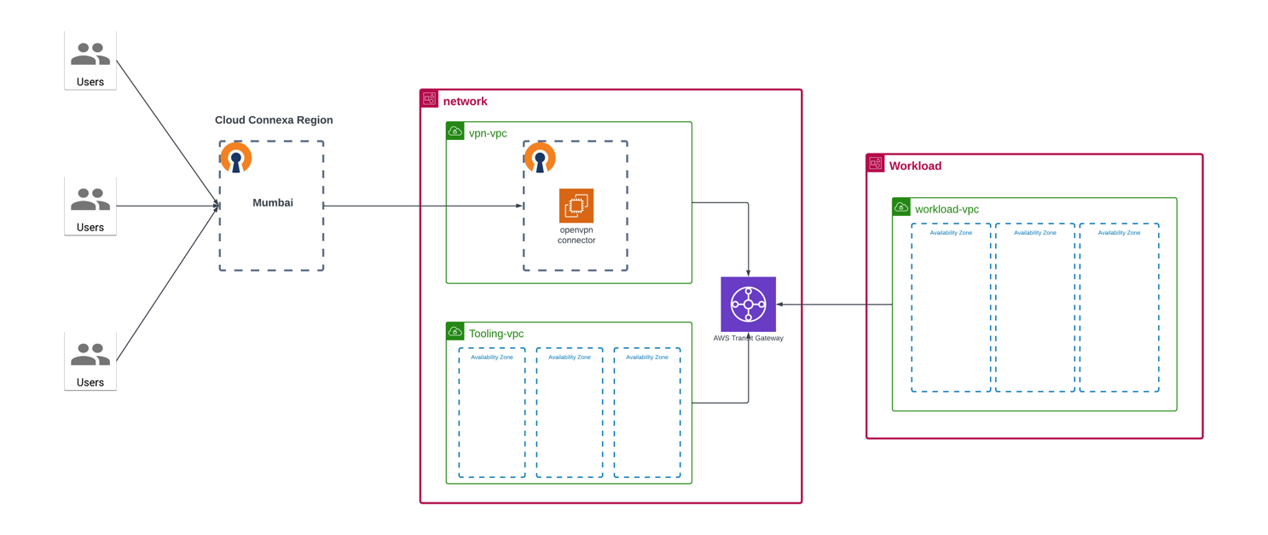
Multiple users will use OpenVPN client on their local machines to establish connectivity to the AWS network using the Open VPN Cloud Connector via the OpenVPN Cloud Connexa in Mumbai region. The cloud connector will be deployed in the network account in the shared services OU, A Connector is a term used to describe a special type of Device (CloudConnexa Device) whose primary function is to provide CloudConnexa connectivity to a private Network subnet (CloudConnexa Subnet) or private application server (CloudConnexa Host). Once the traffic reaches the network it would be routed to different VPCs via the Transit Gateway.

Onprem Connectivity to AWS
<AWS S2S VPN>

AWS DNS
Amazon Route 53 is a highly available and scalable Domain Name System (DNS) web service. AllCargo Logistics (Gati) will use Route 53 to perform three main functions in any combination:
- Domain registration.
- DNS routing.
- Health checking.
Assign and access custom domain names in your Amazon Virtual Private Cloud (VPC). Use internal AWS resources and servers without exposing DNS data to the public Internet.
Every account will have its own Route53 private hosted zone which will be used for the DNS resolution in the respective accounts.

Cross Account DNS Resolution
All the individual accounts will have its own route53 hosted zone which will perform the DNS resolution and for cross account DNS resolution we will associate the VPC to the r53 hosted zones so that every VPC will be able to resolve the private domains hosted in the respective R53 hosted zones.
The below diagram shows the cross account DNS resolution where it depicts the DNS resolution across the tooling account and the workload account. The 2 VPC’s in the workload account(ingress-vpc and workload-vpc) are by default associated with the private hosted zone workload.internal and the VPC in the tooling account tooling-vpc is by default associated with the private hosted zone tooling.internal. These hosted zones along with the VPC’s in the own account are also associated with the VPC’s in the other accounts to ensure that the DNS resolution for the resources in the workload-vpc or the ingress-vpc also can resolve the private DNS in the tooling.internal hosted zone and the resources in the tooling-vpc also can resolve the private DNS in the workload.internal private hosted zone.
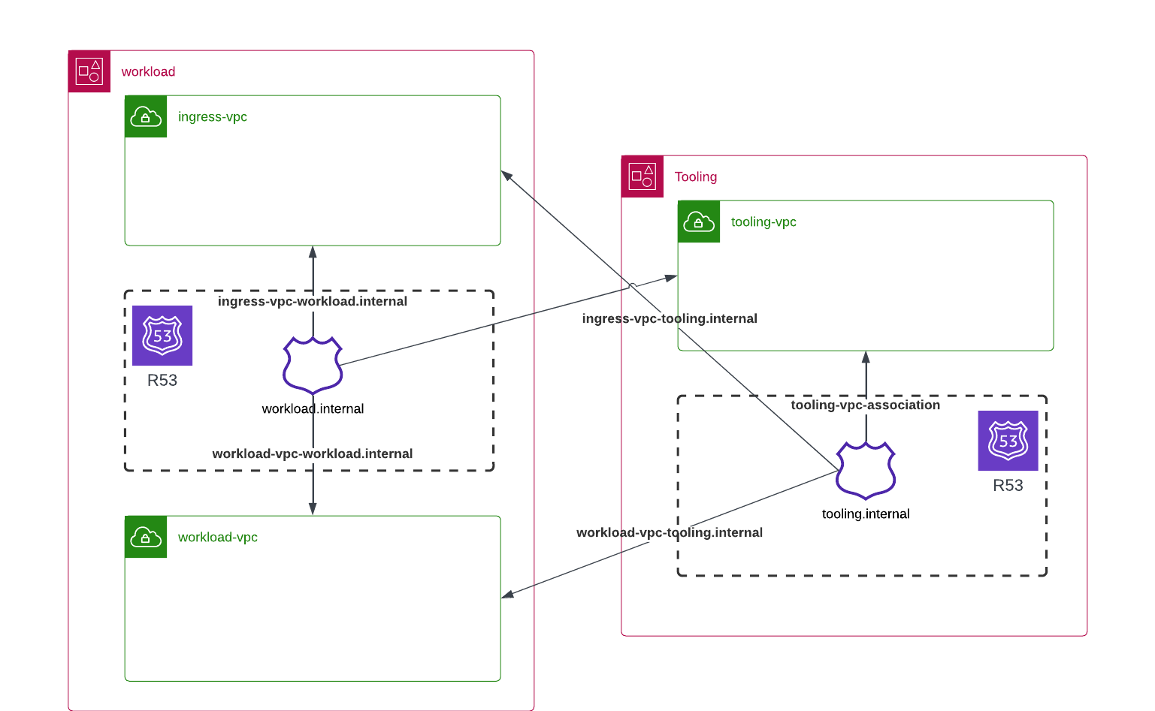

Security

Service Control Policies (SCP)
Applying appropriate config rules and SCP’s. Below are the SCPs by default which will be applied to each OU.
Root OU
- Deny account from leaving organization.
- Deny access to specific regions (reduce surface area).
- Block service access to root user.
- Prevent users from modifying Amazon S3 block public access at the account level (data protection).
- Prevent escalation of privileges.
- Allow only approved services (reduce surface area).
- Deny account region enable and disable actions.
- Deny access to AWS based on the requested AWS region.
- Deny enabling and disabling AWS Config.
- Deny users from disabling AWS Security hub.
- Prevent users from disabling security tools like Amazon GuardDuty, AWS Config Amazon GuardDuty, AWS Config, AWS CloudTrail, AWS Inspector
Production & NONProduction OU
- Deny creating an Internet Gateway (reduce surface area).
- Deny users from deleting Amazon VPC flow logs.
- Deny creation of default VPC and Subnet.
- Deny disabling default EBS encryption.
- Deny Amazon Virtual Private Network (VPN) connections.
- Deny KMS key deletion.
- Protect privileged policies from being updated/deleted.
- Deny users from deleting Amazon S3 Buckets or objects.
- Deny ACL disablement for all new buckets (bucket owner enforced).
- Deny users from modifying S3 Block Public Access (Account-Level).
- Prevent any VPC that doesn't already have internet access from getting it.
- Mandate a tag for S3 data classification (data protection).
- Require MFA for resource deletion (data protection).
- Ensure S3 objects are encrypted when uploaded to buckets (data protection).
- Deny creation of default VPC and Subnet.
- Deny disabling default EBS encryption.
Shared Services OU
- Deny Amazon Virtual Private Network (VPN) connections.
- Deny VPC peering.
- Deny KMS key deletion.
- Protect privileged policies from being updated/deleted.
- Deny key actions on Route53 DNS hosted zones.
- Deny AWS Backup deletion and changes to configuration.
- Deny users from modifying S3 Block Public Access (Account-Level).
- Prevent any VPC that doesn't already have internet access from getting it.
Security OU
- Prevent users from disabling CloudWatch or altering its configuration.
- Deny deletion of AWS Access Analyzer and findings in an account.
- Deny modifications to specific AWS CloudTrail trails.
- Protect disabling/deleting Amazon Macie.
- Deny deletion or disassociation of members and invitations from AWS SecurityHub.
- Deny the root user from performing actions other than modification to S3 bucket policy.
- Deny member accounts from leaving your AWS organization.
- Deny unwarranted IAM Federation creation and modification.
- Protect privileged policies from being updated/deleted.

Security Lake
Security Lake creates a purpose-built security data lake in your account. Security Lake collects log and event data from cloud, on-premises, and custom data sources across accounts and Regions. The service stores the gathered logs in your Amazon Simple Storage Service (S3) buckets, so you retain complete control and ownership over your data.
Security Lake automatically collects logs for the following services:
- AWS CloudTrail
- Amazon Virtual Private Cloud (VPC)
- Amazon Route 53
- Amazon Simple Storage Service (S3)
- AWS Lambda
It also collects security findings through AWS Security Hub for the following services:
- AWS Config
- AWS Firewall Manager
- Amazon GuardDuty
- AWS Health
- AWS Identity and Access Management (IAM) Access Analyzer
- Amazon Inspector
- Amazon Macie
- AWS Systems Manager Patch Manager
Security Lake automatically normalizes AWS log and security findings to OCSF. You can add data from third-party security solutions, other cloud sources, and your custom data such as logs from internal applications or network infrastructure that you have converted into the OCSF format. With support for OCSF, Security Lake centralizes, transforms, and makes your security data available to your preferred analytics tools.
In Organizations, the account that you use to create the organization is called the management account. To integrate Security Lake with Organizations, the management account must designate a delegated Security Lake administrator account for the organization.
The delegated Security Lake administrator can enable Security Lake and configure Security Lake settings for member accounts. The delegated administrator can collect logs and events across the organization in all AWS Regions where Security Lake is enabled (regardless of which Regional endpoint they're currently using). The delegated administrator can also configure Security Lake to automatically collect log and event data for new organization accounts.
AllCargo Logistics (GATI) will enable Security Lake services at the organization level and configure the security-tooling account as a delegated administrator.
AllCargo Logistics (GATI) uses QRadar as the SIEM tool for aggregating the security logs. IBM Security QRadar SIEM with UAX integrates Security Lake with an analytics platform that identifies and prevents threats across hybrid clouds. This integration supports both data access and query access.

AWS Security Hub
AWS Security Hub consumes, aggregates, and analyses security findings from various supported AWS and third-party products. Security Hub also generates its own findings as the result of running automated and continuous checks against the compliance rules in the supported security standards. These checks provide a compliance score and identify specific accounts and resources that require attention.

Security Hub supports the below standards:
<Customer need to confirm on the standards>
- CIS AWS Foundations, follows the CIS Benchmark for CIS AWS Foundations Benchmark, v.1.2, Level 1/2.
- AWS Foundational Security Best Practices, is a standard set of controls that detect when your deployed accounts and resources deviate from security best practices. It continuously evaluates all the AWS accounts and workloads to quickly identify areas of deviation from best practices. It provides actionable and prescriptive guidance on how to improve and maintain your organization’s security posture. The controls include best practices from multiple AWS services. Each control is assigned a category that reflects the security function that it applies to.
AWS Security Hub provides a centralized view for monitoring and managing findings to support multi-account and multi-region configurations, across the below services:
- Amazon GuardDuty
- Amazon Inspector
- IAM Access Analyzer
- Amazon Macie
- AWS Firewall Manager
- Other 3rd Party Partner Solutions
AllCargo Logistics (Gati) will enable Security Hub at the organization level and configure the security-tooling account as a delegated administrator.

AWS GuardDuty
Amazon GuardDuty is an intelligent threat detection service that provides customers with an accurate and easy way to continuously monitor and protect their AWS accounts and workloads. GuardDuty analyses billions of events across AllCargo Logistics (Gati) AWS accounts from AWS CloudTrail (AWS user and API activity in AllCargo Logistics (Gati) accounts), Amazon VPC Flow Logs (network traffic data), and DNS Logs (name query patterns). Amazon GuardDuty threat detection identifies activity that can be associated with account compromise, instance compromise, and malicious reconnaissance.
For example, GuardDuty detects unusual API calls, suspicious outbound communications to known malicious IP addresses, or possible data theft using DNS queries as the transport mechanism. GuardDuty delivers more accurate findings using machine learning enriched by threat intelligence, such as lists of malicious IPs and domains. At All Cargo Logistics (GATI) the deployed GuardDuty solution will delegate the security-tooling account as the GuardDuty administrator account of the AWS Control Tower managed organization. It will add all existing AWS Control Tower accounts as GuardDuty members of the GuardDuty administrator and will export GuardDuty findings from the GuardDuty management account to a single S3 bucket in the AWS Control Tower log-archive account.
Integrating Guard Duty with Lambda for Remediation
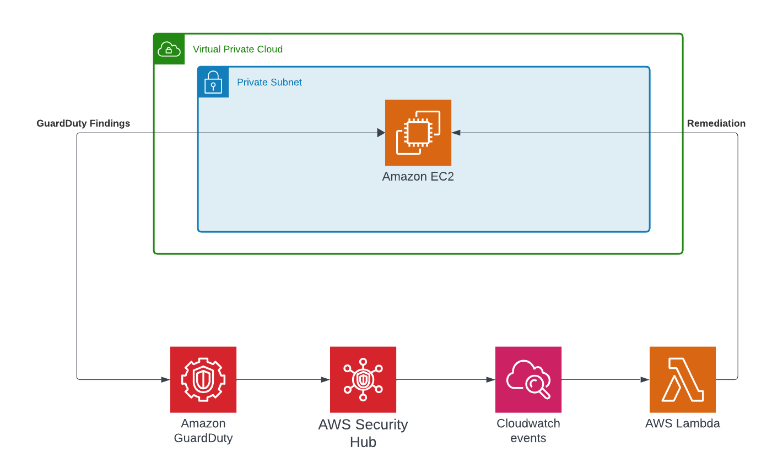
AWS Lambda functions can be used to take custom remediation actions for security threats detected by GuardDuty. Below are the steps.
- Set up an AWS Lambda function to perform your desired remediation action. This Lambda will run your custom logic when invoked.
- Create an AWS CloudWatch Events rule that triggers on GuardDuty findings. Have this invoke your Lambda function.
- In the Lambda function, retrieve details about the GuardDuty finding from the event payload. This includes information like the affected resource, threat type, etc.
- Use the finding details to determine what remediation actions should be taken. For example:
  - Automatically stop compromised EC2 instances.
  - Remove incorrect IAM policies.
  - Disable affected user accounts.
  - Query other services to gather forensic data.
- Execute the appropriate remediation actions using the AWS API/SDK based on the finding type and resource details.
- Optionally send notifications, update logs or metrics to monitor remediation status.

AWS Inspector
Amazon Inspector is an automated vulnerability management service that continually scans Amazon EC2 and container workloads for software vulnerabilities and unintended network exposure.
Using Amazon Inspector you can manage multiple accounts that are associated through AWS Organizations by simply delegating an administrator account for Amazon Inspector. The delegated administrator manages Amazon Inspector for the organization and is granted special permissions to perform tasks on behalf of your organization such as:
- Enable or disable scans for member accounts
- View aggregated finding data from the entire organization
- Create and manage suppression rules
At All Cargo Logistics (GATI) the deployed AWS Inspector solution will delegate the security-tooling account as the GuardDuty administrator account of the AWS Control Tower managed organization

AWS Conformance Packs
A conformance pack is a collection of AWS Config rules and remediation actions that can be easily deployed as a single entity in an account and a Region or across an organization in AWS Organizations, to support multi-accounts.
Conformance packs are created by authoring a YAML template (similar to CloudFormation) that contains a list of AWS Config managed or custom rules and remediation actions. Templates exist as samples for using AWS Config rules and remediation actions within a conformance pack. They do not guarantee thorough compliance check as is. You need to modify the template by adding more AWS Config rules to meet AllCargo Logistics (Gati) requirements to ensure thorough compliance of your AWS resources.
- Operational Best Practices for AWS Well Architected Security Pillar
- Operational Best Practices for AWS Well Architected Reliability Pillar
- Operational Best Practices for Amazon DynamoDB
- Operational Best Practices for Amazon S3
- Operational Best Practices for AWS Identity and Access Management
- Operational Best Practices for CIS
- Operational Best Practices for NIST CSF
- Operational Best Practices for PCI-DSS
- AWS Control Tower Detective Guardrails

Encryption (EAR/EAT)
As per the Well Architected Framework all the resources and applications deployed in AWS will be encrypted at rest and transit using KMS and ACM respectively.
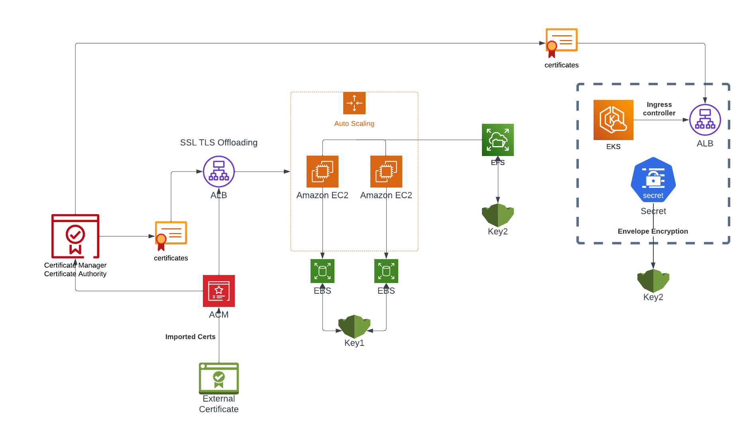
The above figure shows the usecase of how all the AWS resources are encrypted at rest and transit. Any load balancers deployed on AWS in front of an Auto Scaling Group or provisioned by an Ingress controller will be encrypted at transit using TLS certificates created by the AWS Certificate Manager issued by a Private Certificate Authority, All these certificates used for encryption at transit issued by the AWS private CA will be auto renewed every year without any manual intervention if it is issued by the private CA created in AWS. But any certificates which are issued externally would be deployed on to AWS by importing them in to AWS Certificate Manager and those certificates cannot be automatically renewed and will have to be reimported when expired.
For encryption at rest all the AWS resources like EBS volumes, EC2 instances and EKS clusters are encrypted using the KMS keys.

Operational Excellence

Backup
AWS Backup is a fully managed backup service centralizing and automating the backup of data across AWS services. AWS Backup provides an orchestration layer that integrates Amazon CloudWatch, AWS CloudTrail, AWS Identity and Access Management (IAM), AWS Organizations, and other services. This centralized, AWS Cloud native solution provides global backup capabilities that can help you achieve your disaster recovery and compliance requirements. Using AWS Backup, you can centrally configure backup policies and monitor backup activity for AWS resources.

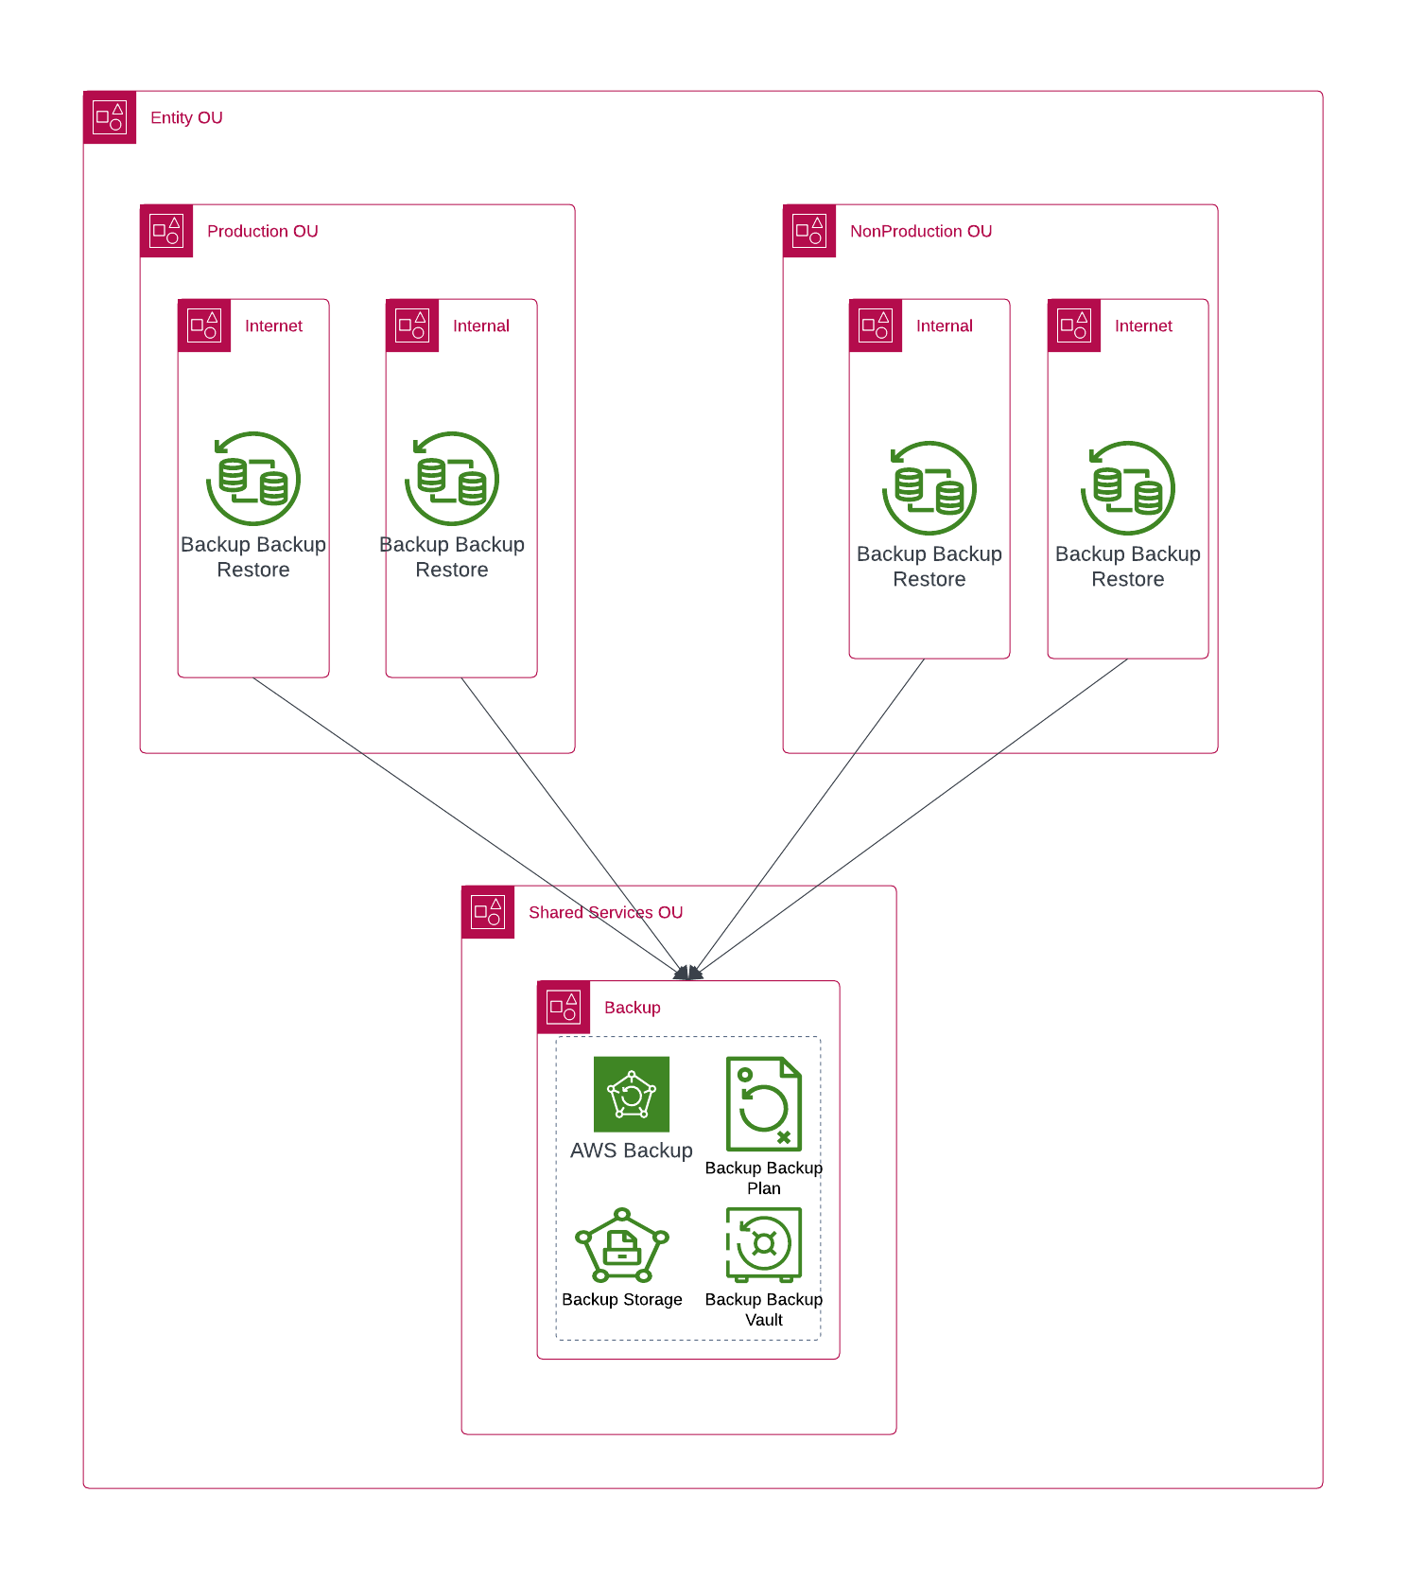
A key differentiator for AWS Backup is support for Organizations. Using this support, you can define and manage backup policies at the organization or organizational unit level and automatically have those policies implemented for each related AWS account and Region. As you onboard new AWS accounts and Regions, you don’t have to define and manage backup plans separately.

AWS Backup can make it easier for you to implement an organization-wide backup policy by using tags. You can create separate backup plans that each have unique frequency and retention settings and then create unique key-value pair tags that select the resources to include for backup.
Below table shows information on the Backup plans for each entity based on the compliance requirement.
Backup Plan | Entity | Backup Frequency | Retention | Target Backup Vault | tags
Plan1 | Gati | Daily | 30 days

Disaster Recovery
<To be discussed>

logging and Monitoring
Monitoring allows for to planning for and incident response. Therefore, monitoring is an important part of the well-architected nature of AWS Control Tower. The results of monitoring activities are stored in log files; therefore, logging and monitoring are closely related concepts. When a landing zone is set up, one of the shared accounts created is the log-archive account. This account is dedicated to collect all logs centrally, including logs for all other accounts provisioned under AWS Control Tower. These log files allow administrators and auditors to review actions and events that have occurred. As a best practice, collect monitoring data from all the parts of your AWS landscape into the log-archive account to allow for ease in debugging a multi-point failure if one occurs. AWS provides several tools for monitoring resources and activity in your landing zone. For example, the status of your guardrails is monitored constantly. You can see their status at a glance in the AWS Control Tower console. The health and status of the accounts you provisioned in Account Factory also is monitored constantly.

Logging
Control Tower sets up the majority of the base line needed for such monitoring by creating a centralized logging account and auto configuring every created account to send CloudTrail and CloudWatch logs to that centralized account. Logging of actions and events in AWS Control Tower is accomplished automatically through its integration with CloudWatch. All actions are logged, including actions from the AWS Control Tower management account and from your organization's member accounts. Management account actions and events are viewable on the Activities page in the console. Member account actions and events are viewable in log archive files.

Log Retention
All Cargo Logistics (Gati) has a variety of logs that are configured to analyse and troubleshoot issues and as part of the landing zone deployment we will be enabling the logs
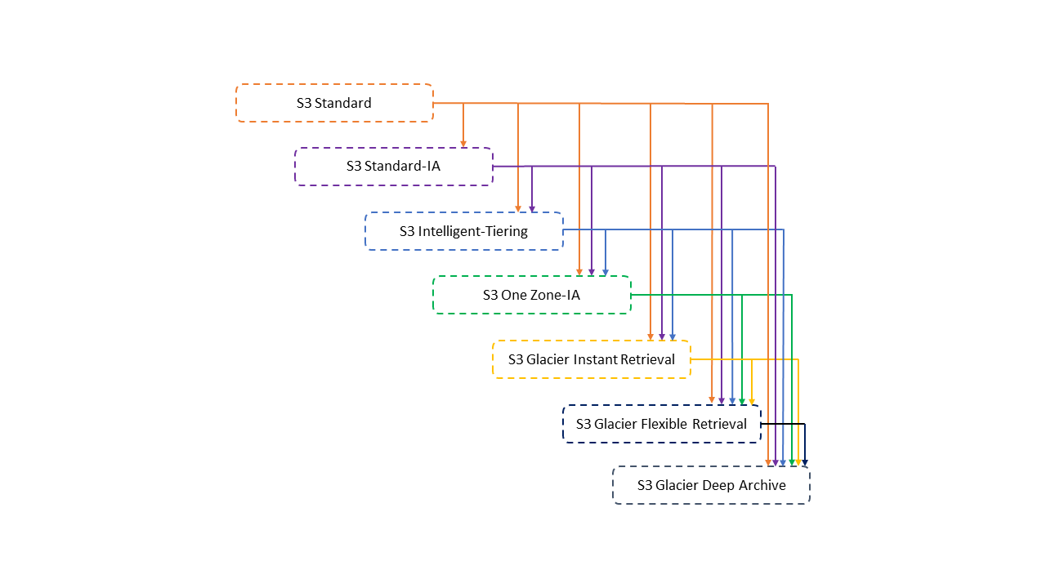

Monitoring
Monitoring is an important part of maintaining the reliability, availability, and performance of AWS Control Tower and other owned AWS solutions. AWS provides the following monitoring tools to watch AWS Control Tower, report when something is wrong, and take automatic actions when appropriate:
- Amazon CloudWatch monitors your AWS resources and applications running on AWS in near real time. You can collect and track metrics, create customized dashboards, and set alarms that notify you or take actions when a specified metric reaches a threshold that you specify. For example, you can have CloudWatch track CPU usage or other metrics of your Amazon EC2 instances and automatically launch new instances when needed.
- Amazon CloudWatch Events delivers a near real-time stream of system events that describe changes in
- Amazon CloudWatch Logs enables you to monitor, store, and access your log files from Amazon EC2 instances, CloudTrail, and other sources. CloudWatch Logs can monitor information in the log files and notify you when certain thresholds are met. You can also archive your log data in highly durable storage.
- AWS CloudTrail captures API calls and related events made by or on behalf of your AWS account and delivers the log files to an Amazon S3 bucket that you specify. You can identify which users and accounts called AWS, the source IP address from which the calls were made, and when the calls occurred. AWS resources. CloudWatch Events enables automated event-driven computing, as you can write rules that watch for certain events and trigger automated actions in other AWS services when these events happen.
For AllCargo Logistics (Gati), the logs from multiple sources will be all aggregated and centralized in the log-archive account deployed by AWS Control Tower.
AWS Control Tower:
- Sets up a default Guardrails.
- Creates AWS Config aggregation authorizations in the security-tooling account.
- Enables CloudTrail in all available AWS Regions.
- Enables AWS Config in all available regions.
- Prevents deletion of Amazon S3 buckets created by AWS Control Tower in the log-archive account.
- Ensures that AWS Config records resource configurations in a consistent manner.
- Disallows changes to the AWS Config aggregation settings.
- Enable Integrity Validation for CloudTrail Log File.
- Sets a retention policy of 365 days on the logs in the log archive.
- Prevents configuration changes to CloudTrail.
- Disallows any policy changes from occurring in the log archive shared account.
- Real-time analysis of activity data by sending CloudTrail events to CloudWatch Logs log files.
As a baseline at AllCargo Logistics (GATI), the following logs will be collected on top of what AWS Control Tower already provides:
- VPC Flow Logs to be enabled at the VPC level in production with additional metadata included, and logged to a centralized S3 bucket in the log-archive account.
- Route53 Resolver query logging to be enabled and logged to a centralized S3 bucket in the log-archive account.
- SSM Session Managers logs to be enabled and pushed to a centralized S3 bucket in the log-archive account.
- S3 Server Access Logs to be enabled in a dedicated S3 bucket at the account level and replicated to a centralized S3 bucket in the log-archive account.
- ELB Access Logs to be enabled in a dedicated S3 bucket at the account level and replicated to a centralized S3 bucket in the log-archive account.
- GuardDuty findings logged to a centralized S3 bucket in the log-archive account.
- Amazon Inspector findings logged to a centralized S3 bucket in the log-archive account.
- Logging retentions for the log-archive account must be determined by AllCargo Logistics (GATI).

The above baseline with config rules for enabling access logging and S3 buckets in member accounts to collect logs in AWS Accounts will be created. This log baseline needs to be deployed automatically through CfCT whenever a new account gets created in AWS Control Tower. It is also decided to enable AWS Config in the Management Account.

Tagging
AWS allows customers to assign metadata to their AWS resources in the form of tags. Each tag is a simple label consisting of a customer-defined key and an optional value that can make it easier to manage, search for, and filter resources by purpose, owner, environment, or other criteria. AWS tags can be used for many purposes.
Once cloud resources start getting created, it rapidly becomes apparent that keeping track of resources, their purpose, and how they should be tracked for billing is necessary. For this, a tagging strategy should be defined and enforced.
Using tagging within AWS has numerous use cases and benefits and is a generally recommended best practice for all AWS customers.
The following basic naming and usage requirements apply to tags:
- Each resource can have a maximum of 50 user created tags.
- System created tags that begin with aws: are reserved for AWS use, and do not count against this limit.
- A tag that begins with the prefix “aws:” cannot be edited or deleted.
- For each resource, each tag key must be unique, and each tag key can have only one value.
- The tag key must be a minimum of 1 and a maximum of 128 Unicode characters in UTF-8.
- The tag value must be a minimum of 0 and a maximum of 256 Unicode characters in UTF-8.
- Allowed characters can vary by AWS service. In general, allowed characters in tags are letters, numbers, spaces representable in UTF-8, and the following characters: _ . : / = + - @
- Tag keys and values are case sensitive. As a best practice, decide on a strategy for capitalizing tags, and consistently implement that strategy across all resource types. For example, decide whether to use Costcenter, costcenter, or CostCenter, and use the same convention for all tags. Avoid using similar tags with inconsistent case treatment.
Note: Some services don't permit tags with an empty value (length of 0).

Tagging Policy
AWS Organizations has the capability to apply a tagging policy. This policy does not ensure that tags are applied but when tags are applied it can ensure they follow a consistent name (casing, spelling, and formatting) as well as that those tags with a defined list of acceptable values can contain only those values.
A JSON document that defines the initial tagging policy at AllCargo Logistics(GATI) will be created. That policy will be deployed to the AWS Organization and activated for the entire organization.

Tagging Strategy
At account level, the following tags will be mandated:
Tag | Required | Type
Environment | Yes | String
Application | Yes | String
Terraform | Yes | String
Owner | Yes | String
Group | Yes | String
Layer | Yes | String
map-migrated | Yes | String

